Lecture 8: Market mapping
Market mapping
- Introduction to market mapping
- Seasonal calendar
- Market maps
- Limitations of market maps
- Seasonal flow reversals

Readings
- FEWs Net (2008) “Market Assessment and Analysis: Learners Notes. Lesson 3: Market Indicators: Annex 3: Policy impacts on markets and population” FAO. pp. 24. http://www.stanford.edu/group/FRI/indonesia/documents/foodpolicy/fronttoc.fm.html
- Timmer, C. P., W.D. Falcon, and S.R. Pearson (1983) Food Policy Analysis. Baltimore: Johns Hopkins University Press: chapter 4, “Marketing Functions, Markets, and Food Price Formation.” doi:10.1016/S0305-750X(96)00132-5 http://www.stanford.edu/group/FRI/indonesia/documents/foodpolicy/fronttoc.fm.html

Introduction to market mapping
Understanding market characteristics is an important first step in gauging market functioning and identifying possible market constraints. Basic market maps identify which physical areas are facing market constraints and can be updated as more information becomes available (Adams and Harvey, 2006).

A map (e.g., a simple road map) plotted with information collected during key informant interviews and focus group discussions can identify surplus areas, market limitations, and weak market functioning. Further, this map can be augmented with additional information on volume, market integration, transaction costs, transportation routes, etc. as it becomes available (e.g., from traders, from supply chain and margin analyses, from policies and practices, and from market integration analyses). Market mapping can be done locally, regionally, or nationally.

How does the analytic assist in answering the relevant MIFIRA sub-question?
While market mapping provides context, it also assists in answering several MIFIRA sub-questions.

1a. Are food insecure households well connected to local markets?
Mapping the local marketshed should give insight into how many and what types of markets are accessible to the targeted communities and households. A larger number of nearby markets indicates better market access at a community level (but not necessarily for certain individuals facing market access limitations).

1b. How will local demand respond to transfers?
Mapping markets also provides insight into how the markets used by food insecure households link with larger markets. The more inter-connected a smaller marketshed is with larger markets, the more likely that the smaller market will be able to increase supply without driving up prices locally.

2a. Where are viable prospective source options?
Identifying major regional and national markets will assist in generating source market supply chains (e.g., those source markets that link to major markets within the distribution area may be more reliable and faster than markets outside of normal supply chains).

Market mapping can also assist with identifying a possible sampling frame. If the intention is to randomly sample households or traders from within a marketshed, understanding which communities rely on which markets is the first step in defining the various marketsheds from which to sample.

Seasonal calendar
The first step in constructing a market map is to understand seasonality in the local marketshed and to determine whether food prices and food availability, and market access by traders and consumers vary by season.

Why Seasonality Matters

- Surplus producing areas and importing areas
Below is an example of the seasonal calendar of maize production in Tanzania. Maize production in Tanzania is either bimodal and unimodal, depending on the location. Note when the harvest seasons are. The seasonal calendar by region is then mapped, showing commodity flows and production levels. If a production shortfall were to occur in one area, an analyst could identify whether such a shortfall would impact neighboring areas or markets.

- Seasonal price variations
Seasonality also matters because prices can change with the season. This inter-season price variability is particularly strong in countries or locations with weak or highly centralized storage and poor credit markets. For example, the seasonal variation in maize prices in Maputo reflects these seasonal patterns of hunger and harvest. In December and January, prices are relatively higher while in May and June, prices are low. The hunger season peaks in December and January, while harvests run April through June.

FEWS-NET Seasonal Calendar for Tanzania

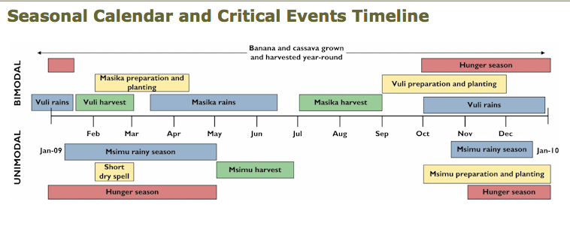

Source: FEWS-NET 2008 http://www.fews.net/pages/timelineview.aspx?gb=tz&tln=en&l=en

FEWS Average Maize Prices in Maputo, Mozambique

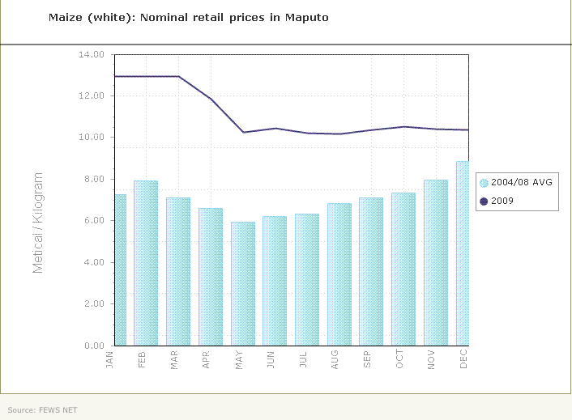

Seasonal calendar guiding topics
The following are guiding topics that may be important to include in a seasonal calendar. Some issues may not be relevant.
- Major weather patterns
- Production cycles of the major consumption crops, and the major cash crop or livestock growth cycle, if relevant. Track more than one if necessary.
- Lean periods / hungry seasons (e.g., in which months of the year do households not have enough food to eat)
- Major regular shocks (e.g., flooding or road travel becomes difficult)
- Seasonal market activity
- Seasons when markets are most active (what is sold or bought by whom)
- Seasons when markets are most quiet and why
- Procurement or distribution activity
- Regular ceremonies or holidays that increase demand (e.g., Eid, Christmas)
- Others as appropriate (e.g., quality if it varies over the year or migration)

Different areas within a country may have a different seasonal calendar. Seasonal calendars are most helpful when paired with analysis of historical price data. Focus on the calendars relevant for distribution and procurement sites. If price data are not available for relevant distribution and procurement sites, generate a seasonal calendar for major production zone and use historical price data for urban areas or for major production zone.

Month | Weather | Production of key staple | Price of staple | Production of cash crop or livestock¹ | Hungry/ lean season | Regular shocks / major holidays | Market Activity | Procurement or distribution activity | Major Holidays
Jan
Feb
March
April
May
June
July
August
Sept
Oct
Nov
Dec

Create an annual timeline using a table similar to the one above (see the footnotes for possible entries in each cell). The seasonal calendar can be overlaid onto a marketshed map, using key informants to understand trade flows across markets or regions and production levels within regions.

FEWS Seasonal Calendar for Maize in Mozambique
The below figure shows one way to present the above tabular information graphically.
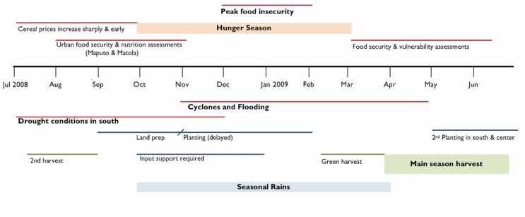
Source: FEWS-NET 2008.

Marketshed map
A marketshed map is a local, regional, or national map plotted with information collected during key informant interviews and focus group discussions.

Using a map (e.g., a simple road map) of the nation, plot information collected from traders, from supply chain and marketing margin analyses, and from market integration analysis (Adams and Harvey, Issue Paper 1, 2006). Identify the main marketing hubs and include approximate numbers of retailers and wholesalers operating in various localities. As information becomes available, identify supply shortfalls, infrastructure damage, or certain routes not considered adequately profitable by traders. Adams and Harvey (2006) note that some areas may have few or no traders, because entitlement failures have hurt local purchasing power and traders cannot profitably operate in those regions. Mapping can help identify such areas and alerting traders to impending cash distributions may give them incentives to resume trading in such regions. An additional mapping strategy is to draw lines connecting pairs of markets with strongly correlated prices for the staple crop (Timmer et al., 1983).

When considering local and regional procurement, also assess whether transporting commodities from the source market to the destination market will face any barriers along the route (e.g., export restrictions, customs delays, diversions). Generally, import requirements can delay delivery relative to local (in-country) purchases, so begin with local market availability and then examine regional availability.

To generate a marketshed map
- First, find a map with the resolution you are looking for, or draw one by hand.
  - The level of detail will depend on what geographic area the map is trying to capture. For example, it can be hand-drawn for a community market map.
- Assess whether seasonality affects trade routes, source markets, number of traders operating, market choices of targeted households
  - If so, create maps by season
  - Different regions may have different seasons (e.g., unimodal versus bimodal)
- Then, map findings from key informant discussions regarding:
  - Main market hubs utilized frequently by food insecure population
  - Smaller markets also utilized by the same population
  - Storage facilities or centers
  - Major supply markets used by wholesalers and retailers in the marketshed
    - Secondary data may already be collected for larger markets that link to affected marketsheds
  - Market routes and roads
  - Any infrastructural damage in the markets or along main route
  - Prices of key commodities in each of the markets
  - Approximate number of retailers and wholesalers
  - As data become available, it is possible to incorporate supply chains, policies and practices, and market integration.
- For prospective local and regional procurement source markets, as data become available also consider including:
  - Production and food supply estimates (FAO /GIEWS; food balance sheets).
  - Estimated procurement (IPP) and transport costs for source market.
  - Routes prone to disruptions, e.g., due to flooding, conflict, customs delays

Limitations of market mapping
A quick mapping of markets focusing on key attributes can identify those most at risk poor functioning (e.g., isolated regions with fewer roads and limited linkages to major surplus or import markets). However, if a response will be geographically dispersed, a detailed mapping of all markets may not be feasible.

In cases where infrastructure has been damaged or routes or markets are blocked, market mapping is a rapid way to assess the existence of alternative routes and alternate, secondary markets. Mapping the market may provide basic, but limited, context, particularly in regions of chronic food insecurity.

If prices have changed within a distribution zone or procurement zone, market mapping may usefully identify (or rule out) any market-specific factors that may be causing price changes (e.g., infrastructural damage, breakages in supply chains, out-migrations of traders, localized production failures, increased reliance on markets by households within the marketshed, local security threats).

Sources of information on this type of analytic
Key informant interviews with traders, government officials, field staff, local community members

Example: Map of maize production and trade flows
The FEWS NET map below identifies how maize production flows within the region of northern Tanzania, western Kenya and eastern Uganda throughout the year. This map identifies prospective surplus producing regions as well as regions that tend to import maize. Note that maize flows from Tanzanian border areas into Kenya match with the bimodal Masika maize harvest time in the seasonal calendar shown above. A maize production failure in a surplus region could adversely affect neighboring importing regions. Assessing whether neighboring markets have linkages to other surplus markets or to import markets will elucidate market integration and traders’ abilities to respond to increases in demand.

FEWS-NET Maize Production and Market Flows in Kenya and Tanzania
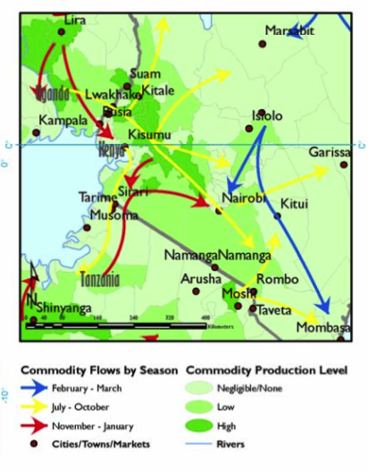
Source: Awuor, T. (2007) “Review of Trade and Markets Relevant to Food Security in the Greater Horn of Africa: A special report by the Famine Early Warning Systems Network (FEWS-NET).” P. 24.

Market maps can be quick and simple, can be layered on existing maps, and are most useful when focusing on issues of local importance.

Seasonal flow reversals
Greater price variability in outlying production areas relative to urban areas is not uncommon in many countries. This is primarily due to seasonal flow reversals (Barrett, J. Development Studies 1996). During harvest times, outlying areas may have lower prices than urban areas. Traders from urban areas purchase harvests and evacuate them to urban areas for storage. During lean seasons, traders then move these products back to the outlying production areas, incurring transactions costs in both directions. During the lean season, these transactions costs drive prices in the outlying areas above urban market prices. Therefore, prices in rural areas may be more variable interseasonally, and follow a different pattern than prices in urban areas.

No activity, Planting, or Harvest
Within a year, when are prices average=A, higher than average=H, lower than average=L?
Indicate months that are associated with increased food insecurity.
Low volume sold to traders = LVS; high volume sold to traders= HVS; low volume bought by traders=LVB; high bought from traders = HVB

